BRAMBLE COCTAIL

Design: Titti Stenke @diwybytitti

Pattern for private use. If you want to use my pattern in other ways please contact me for permission: www.virrkpannan.gmail.com

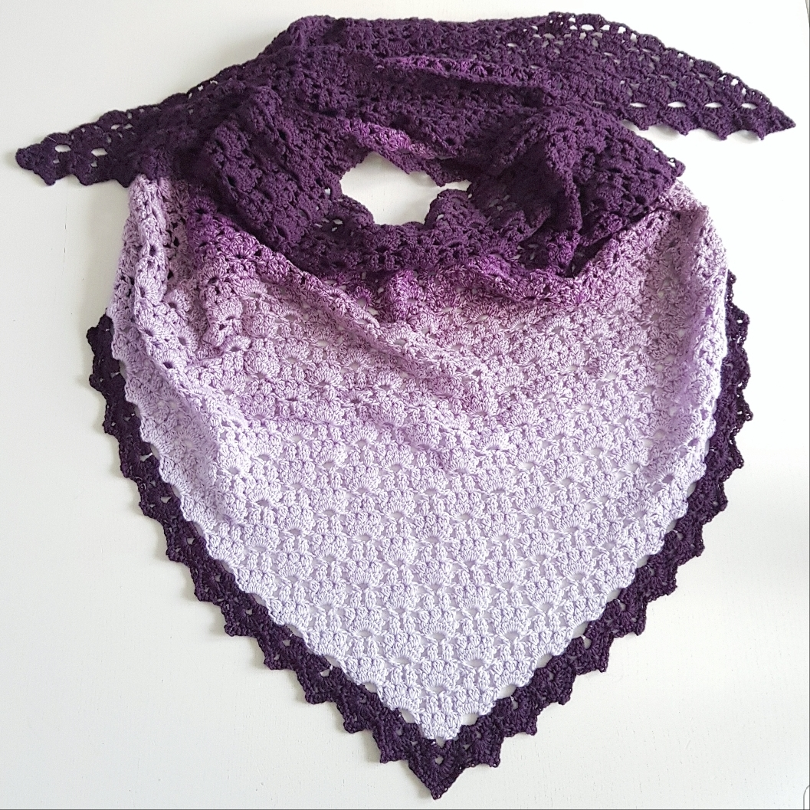

Yarn:.
Scheepjes whirl or whirl ombre, 1 ball
Scheepjes woolly whirl, 1ball
Scheepjes whirlette, 2 balls (3 balls if you want to make the border in a contrast colour)
Katia cotton-alpacka, 6 balls + 1 ball for the edging
Katia stella, 2 balls
Svarta fåret baby merino, or Svarta fåret baby, 11 balls (9+2)

Crochet hook: 3,5 mm
Design: Bramble coctail is a triangle shaped shawl, shaped as the figure below, crocheted from the bottom to the top. The pattern is repetetive, therefore I will show the first rows. Then you keep going in the same way until you get the size you want. If you block your work you will get a nicer result.

Size in centimetres:

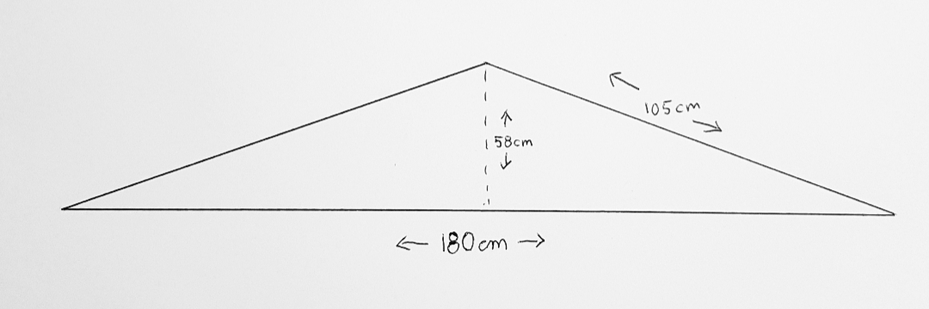

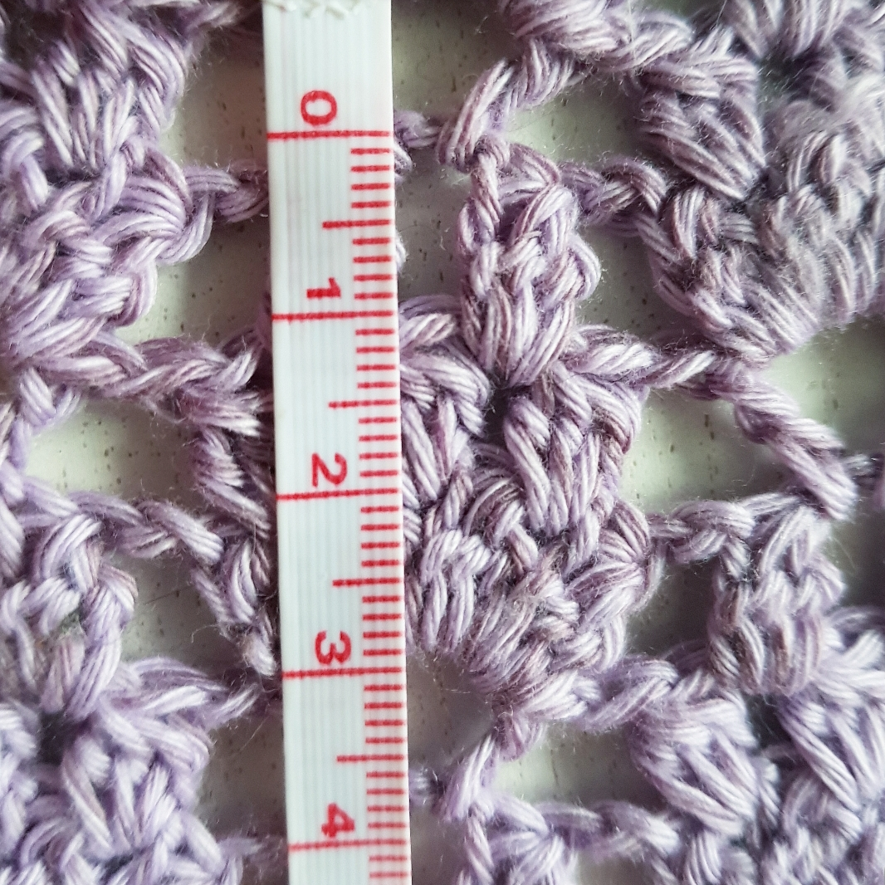

Us crochet terminology

Sl st= slip stitch
Ch= chain
Sc= single crochet
Dc= double crochet
3 dctog= 3 dc together
Tr= treble
Fpsc= front post single crochet
Ch space= chain space
Cluster= a group of dc

1. Ch 7, 1 dc in the 7th chain from the hook. (= the last chain)

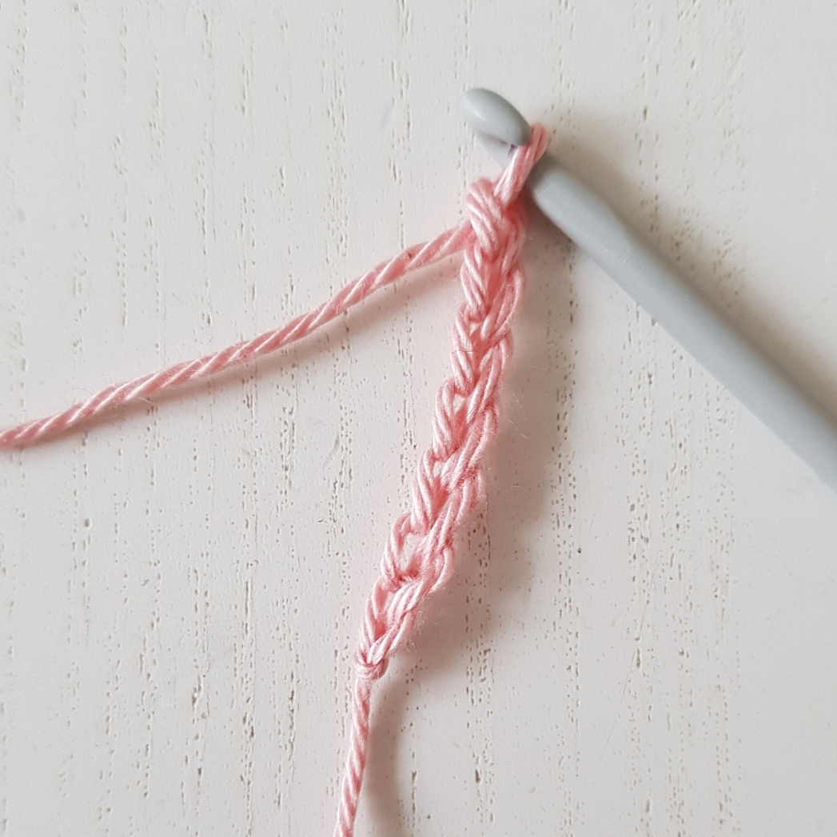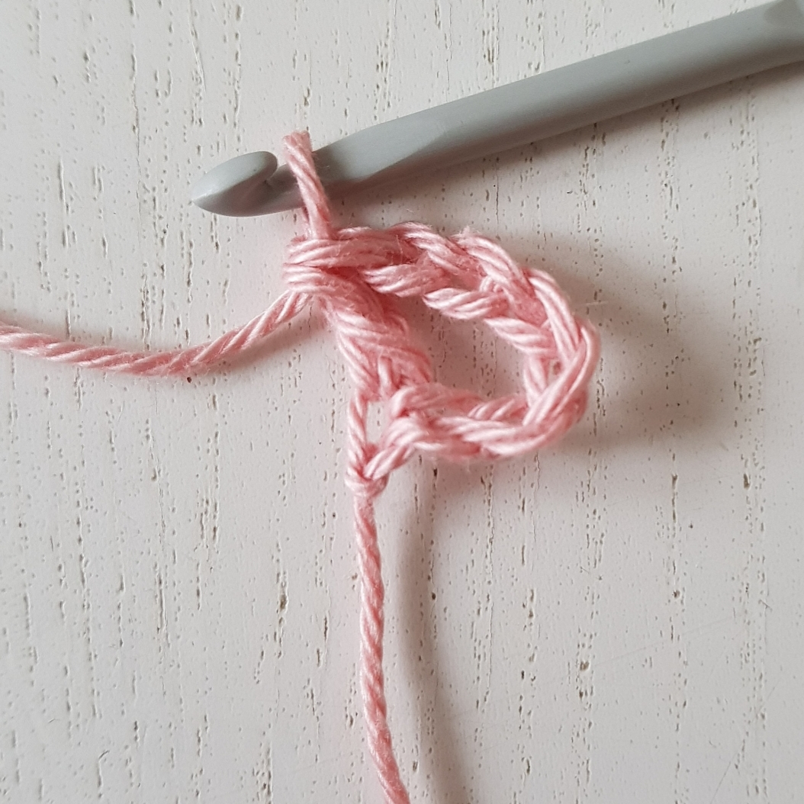

2. Sl st to the ch1-space, ch 2, 2dctog, *ch 1, 3 dctog *, repeat ** 2 more times. Now you have 4 clusters and a ch 1 between each cluster.

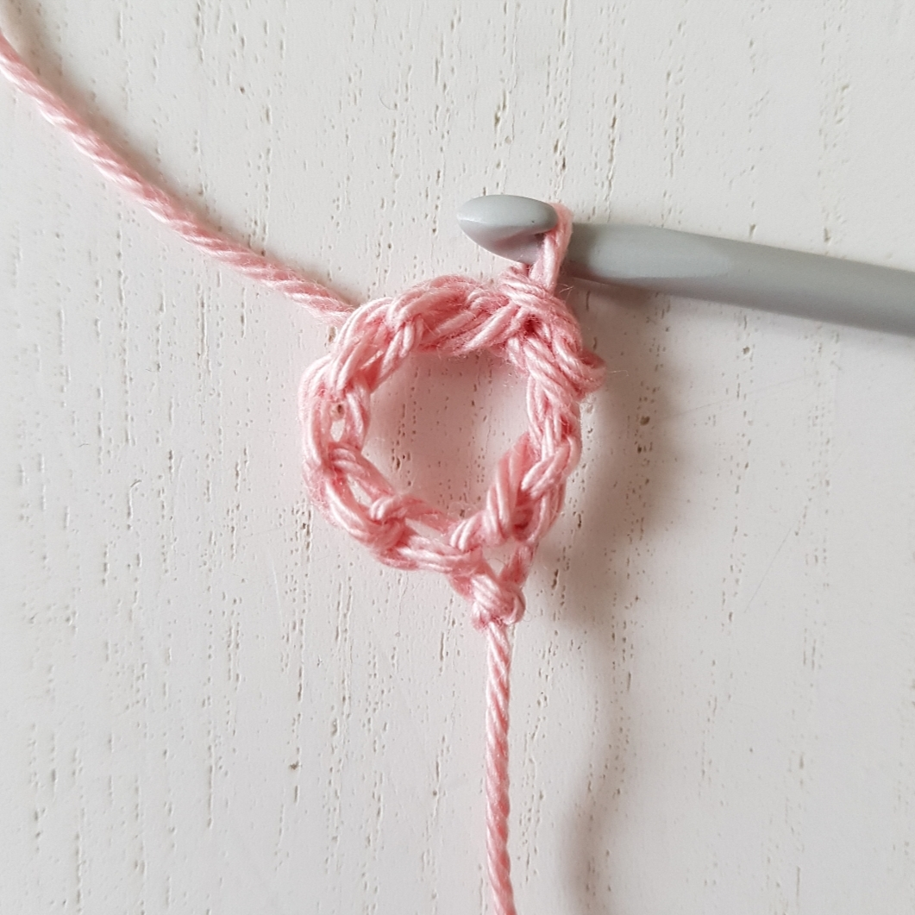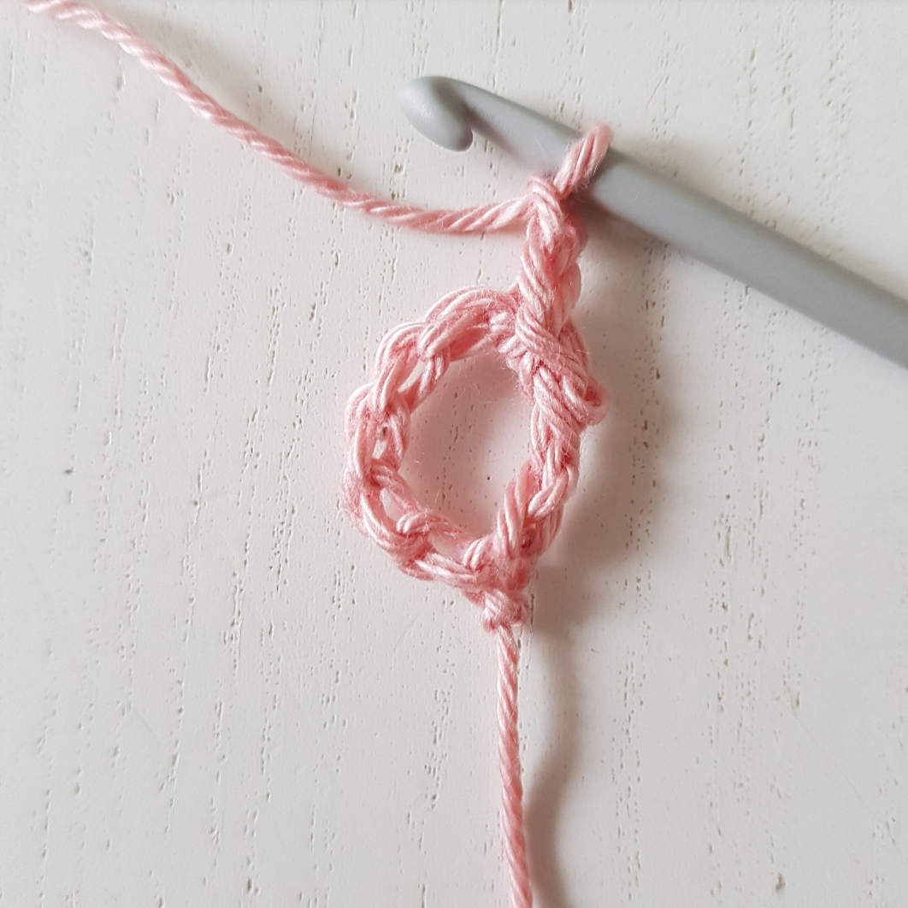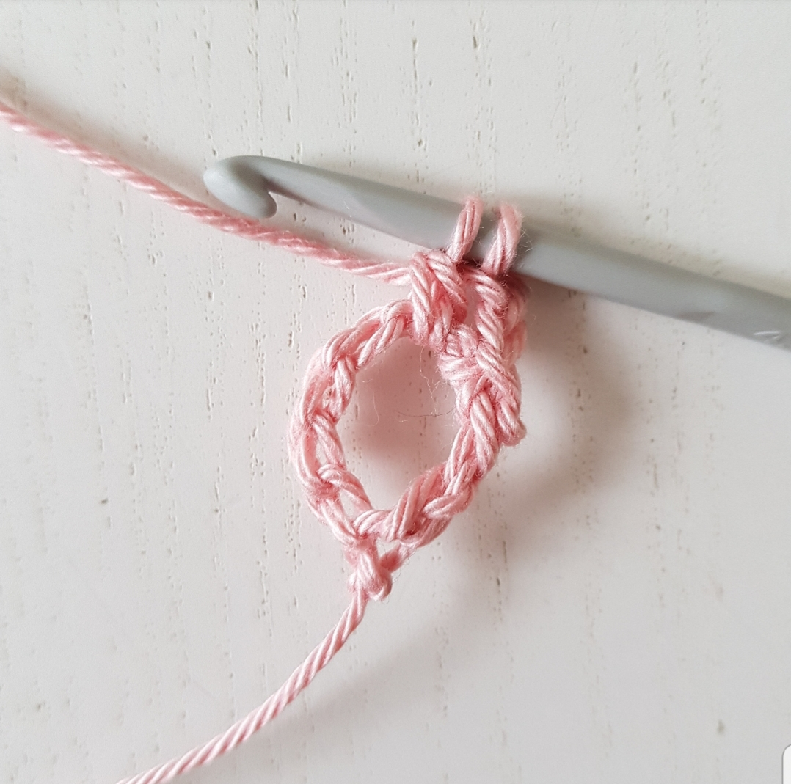
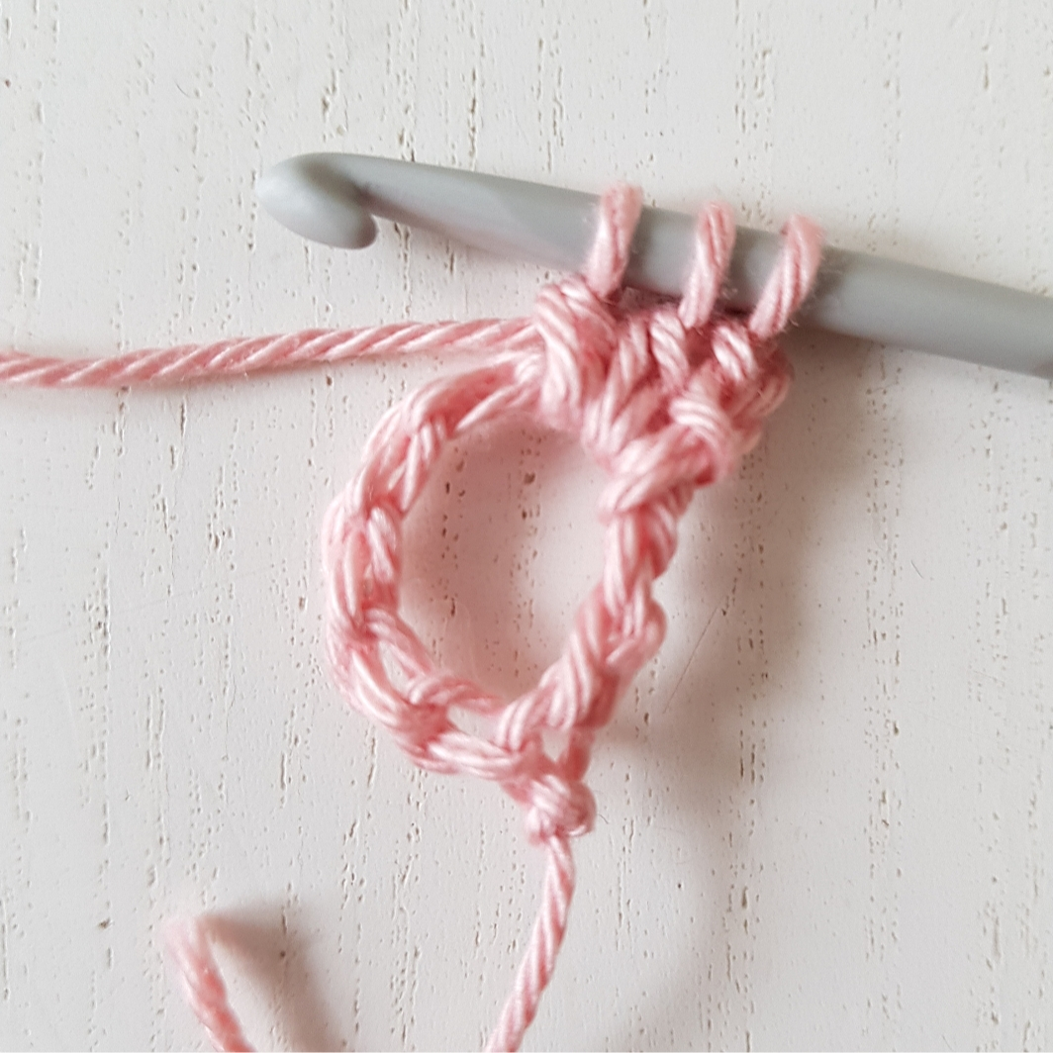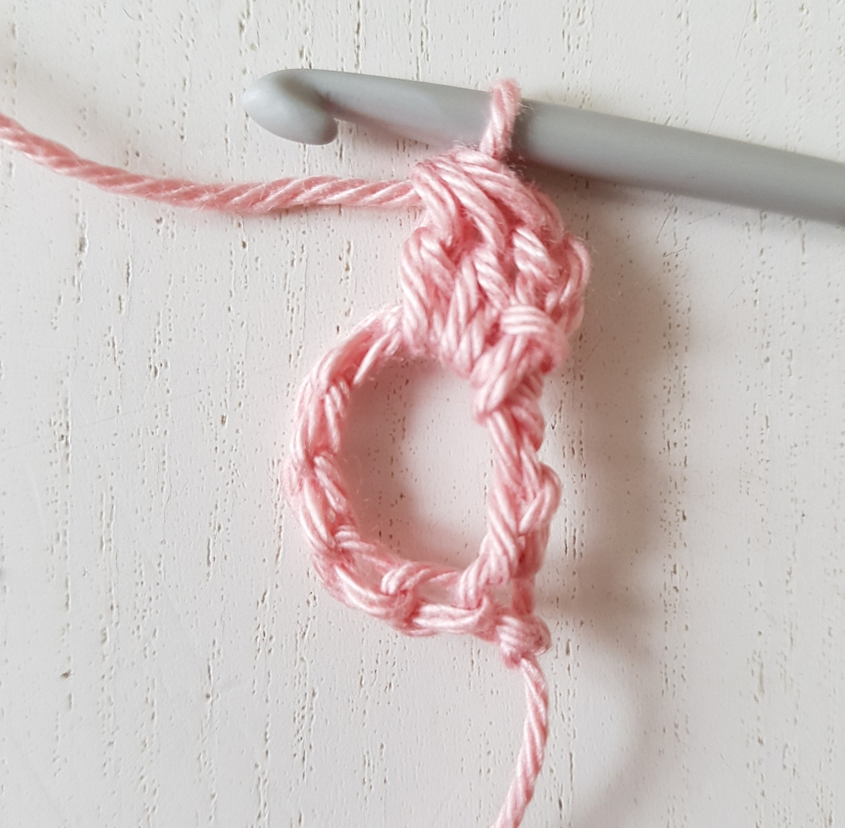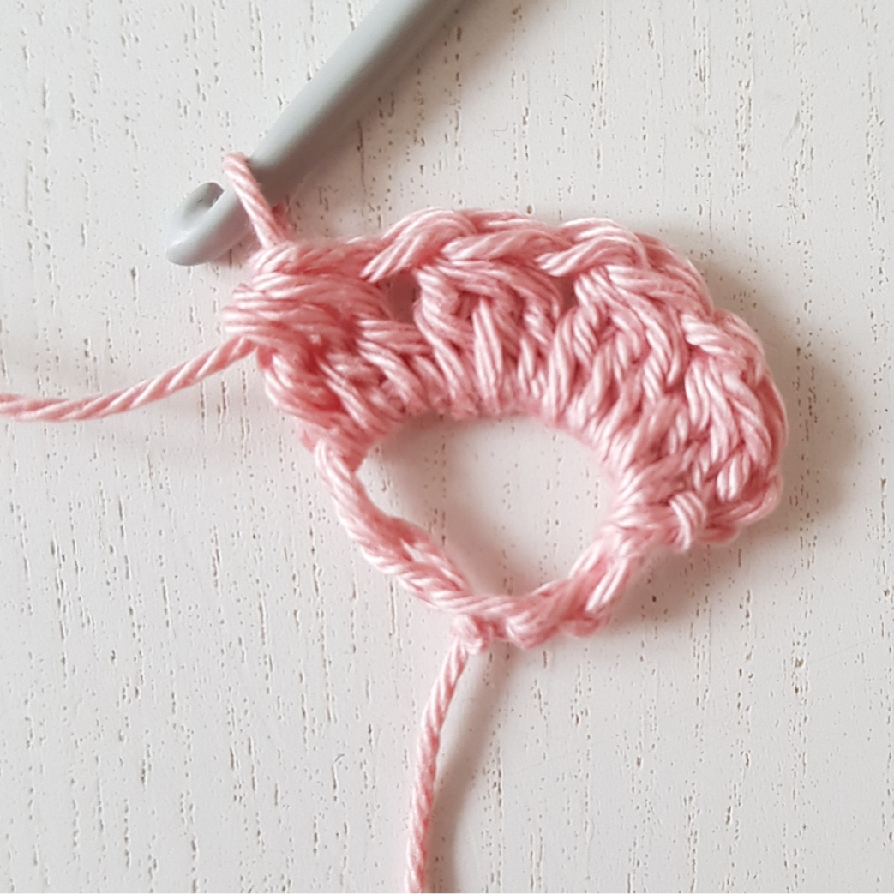

3. Ch 7, 1 dc in the 7th ch from the hook, ch 1, *3 dctog in the ch1-space, ch 1*, repeat ** two more times, (1 dc, ch 3, 1 tr) in the second ch, pointed out in the picture.

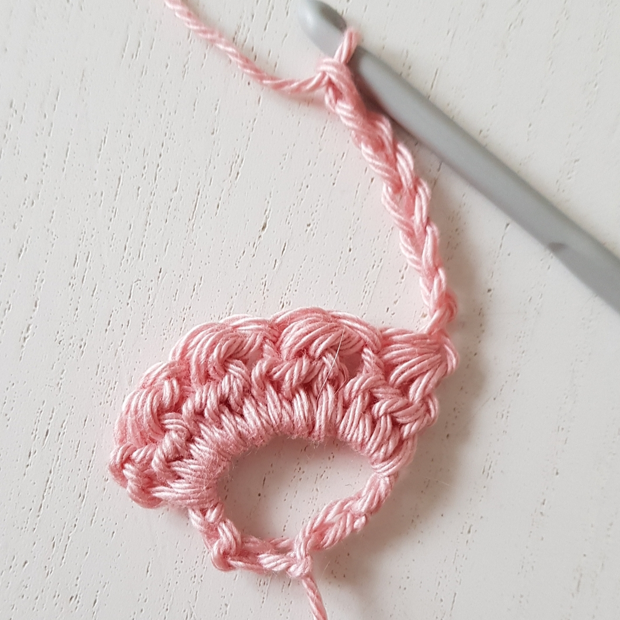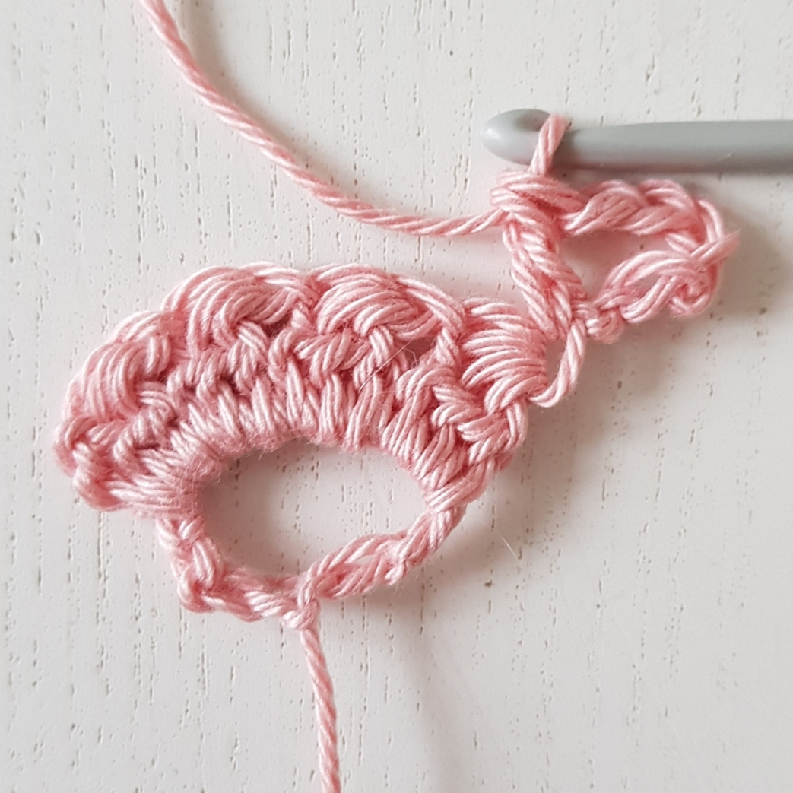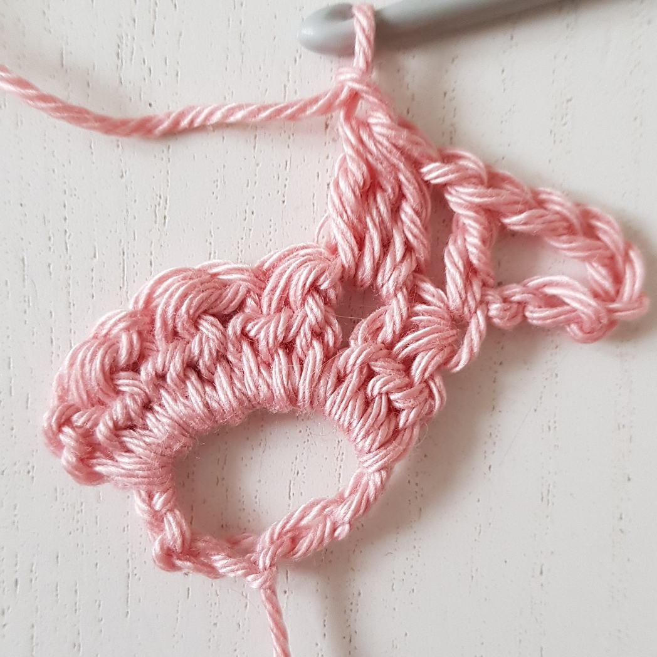
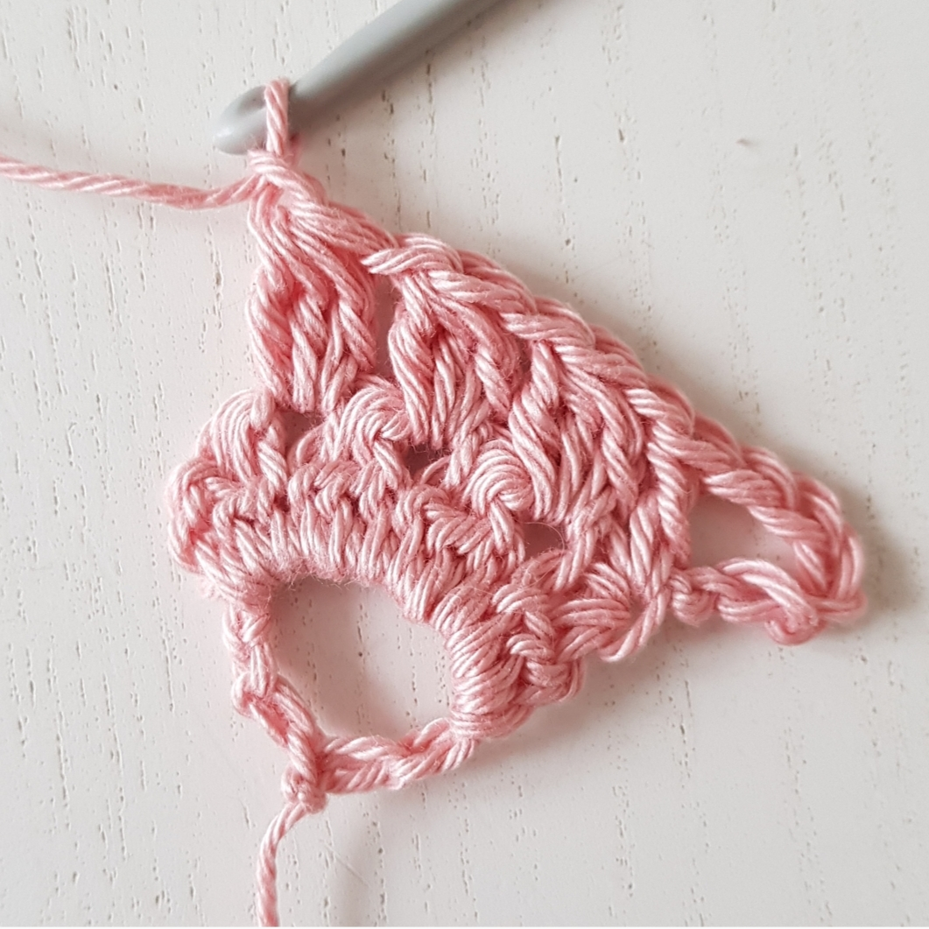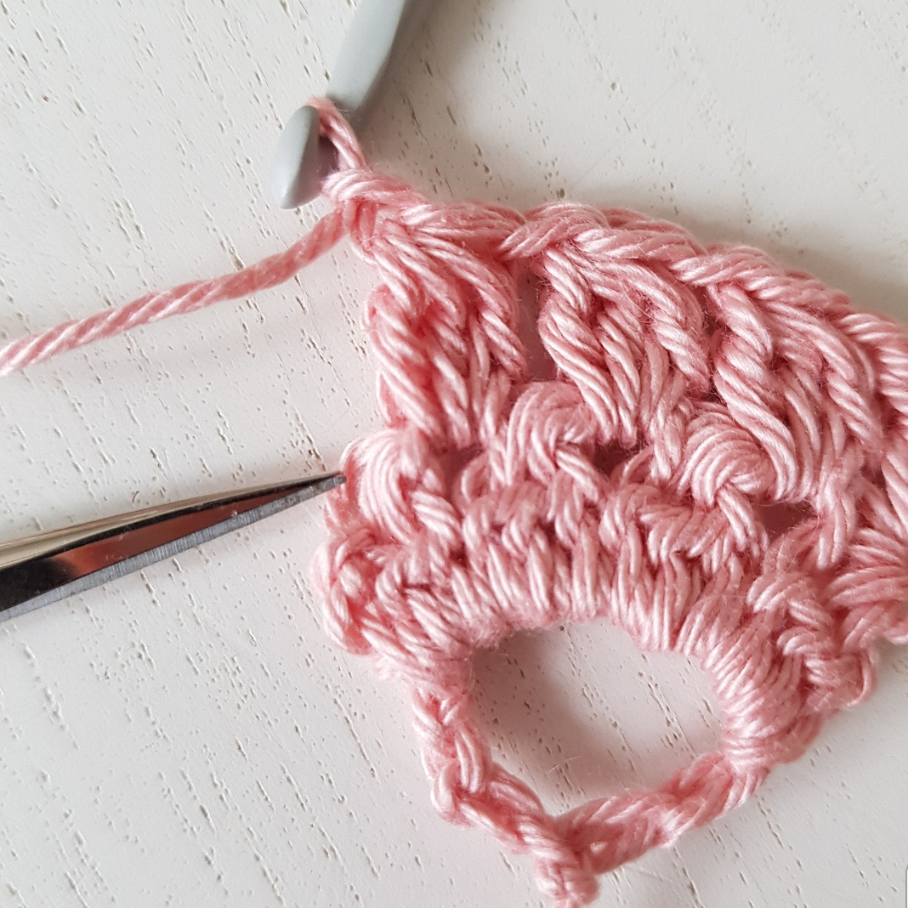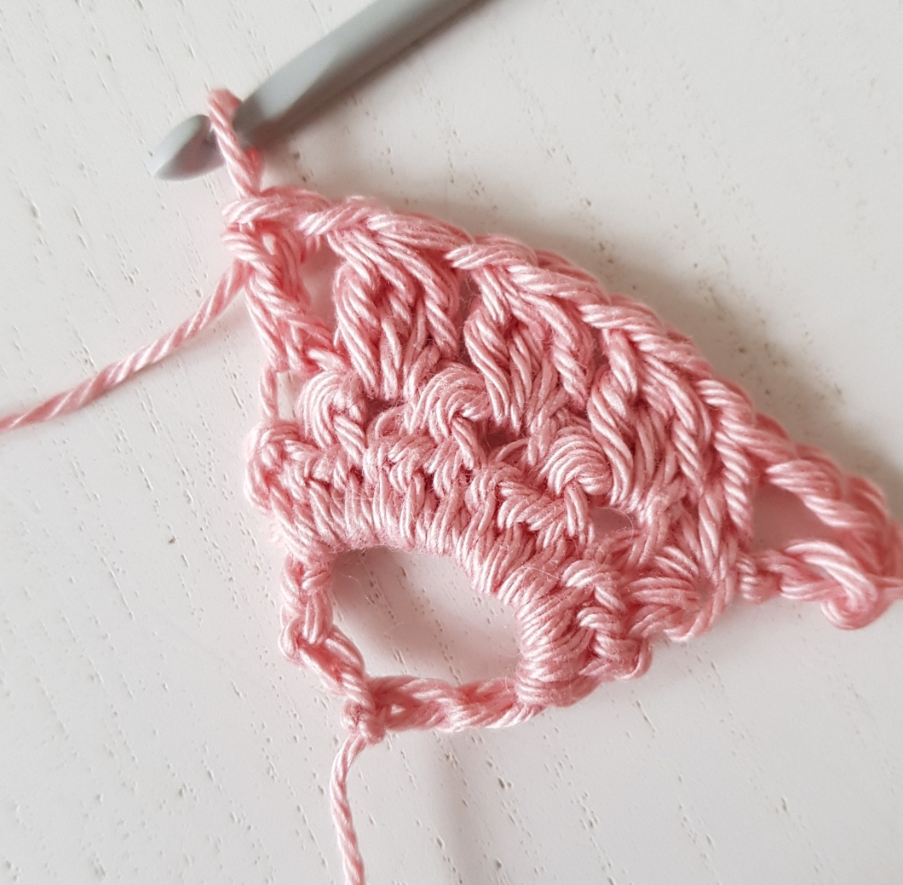
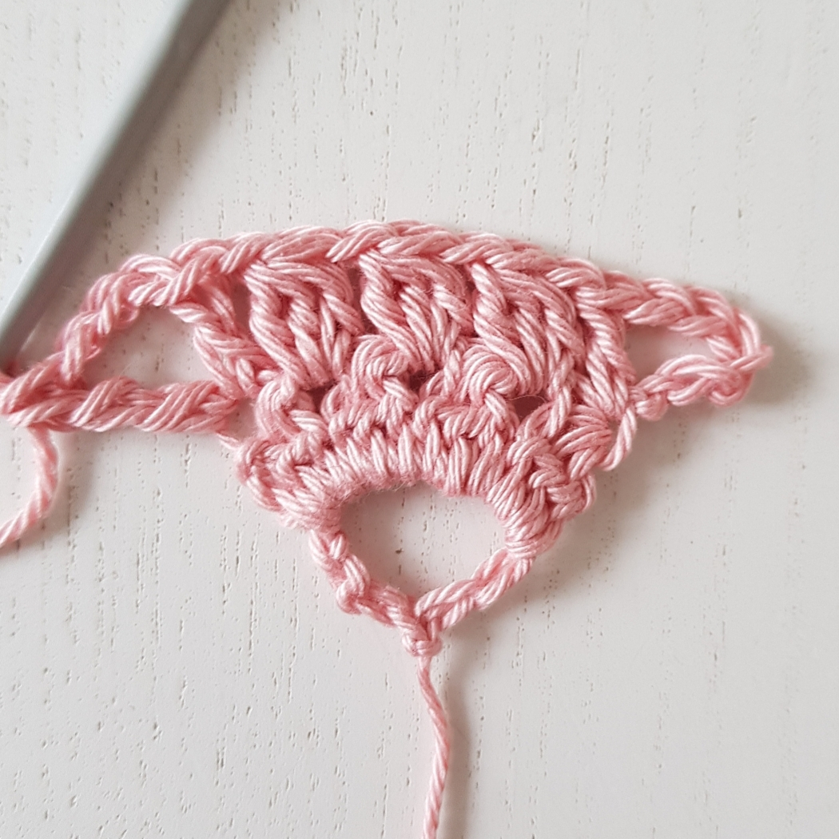

4. Sl st to the ch3-space, ch 2, 2dctog, *ch 1, 3 dctog *, repeat ** two more times. Now you have 4 clusters and a ch 1 between each cluster, ch 1, 3 dctog in the ch1-space between the first and the second cluster, ch 2, 3 dctog between the second and the third cluster, *ch 1, 3 dctog *, repeat ** three more times. Now you have 4 clusters in the last ch3-space as well.

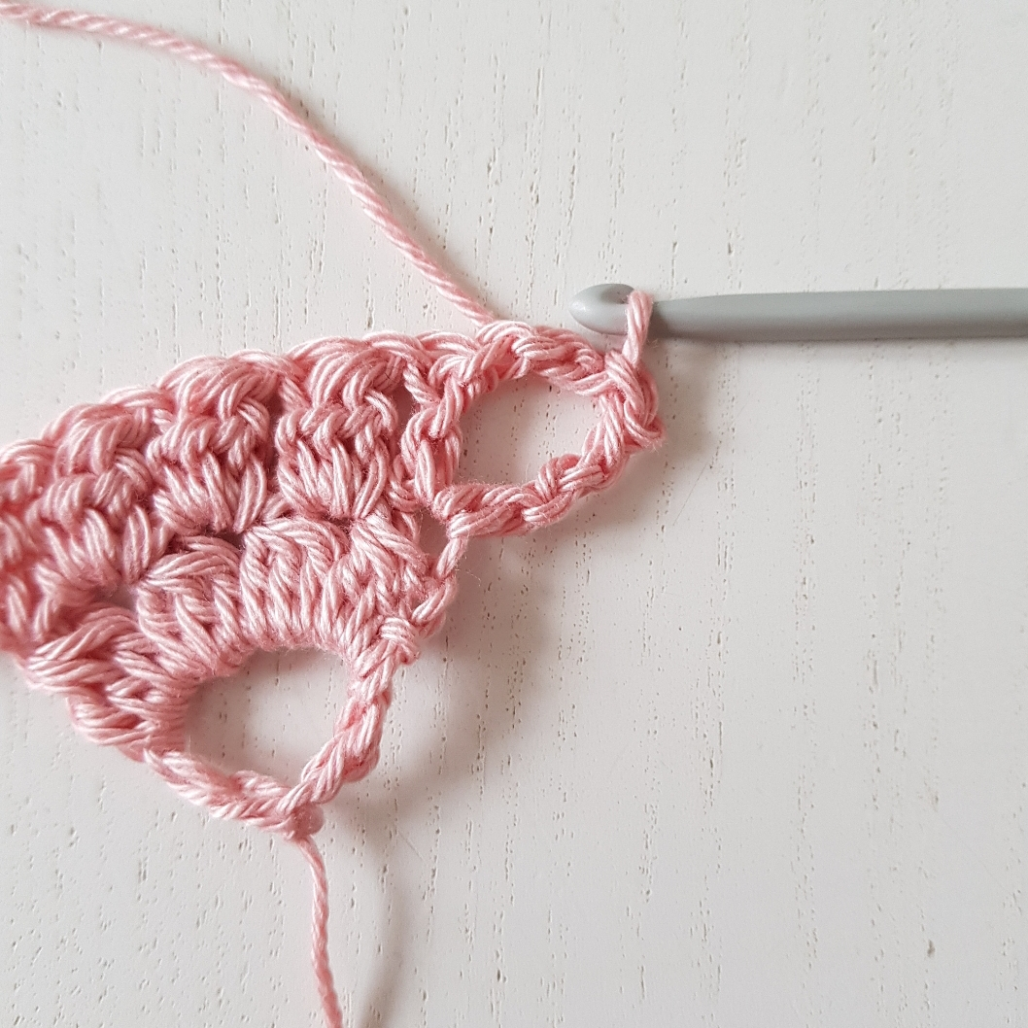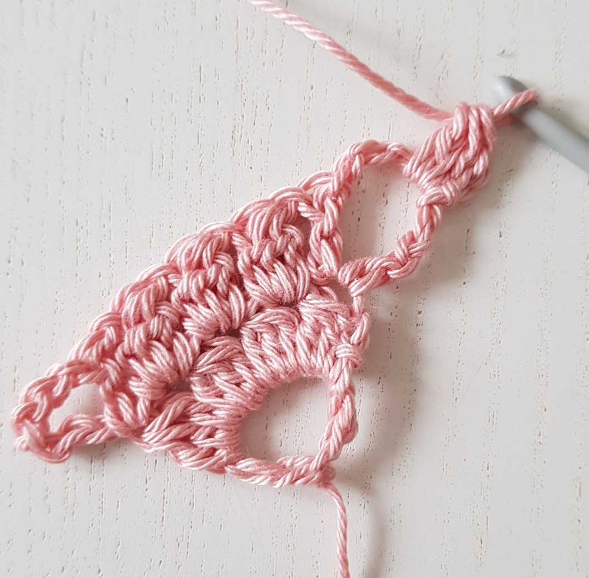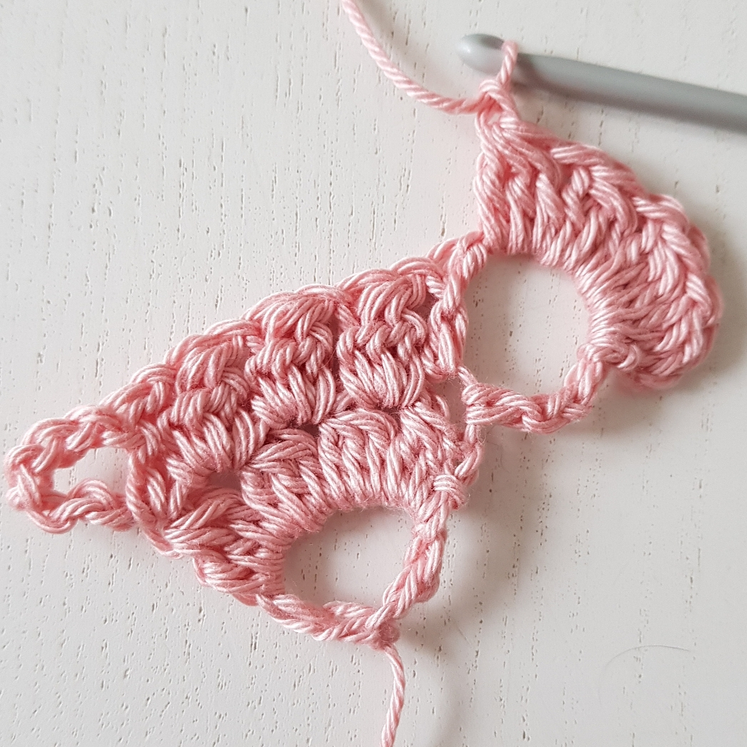
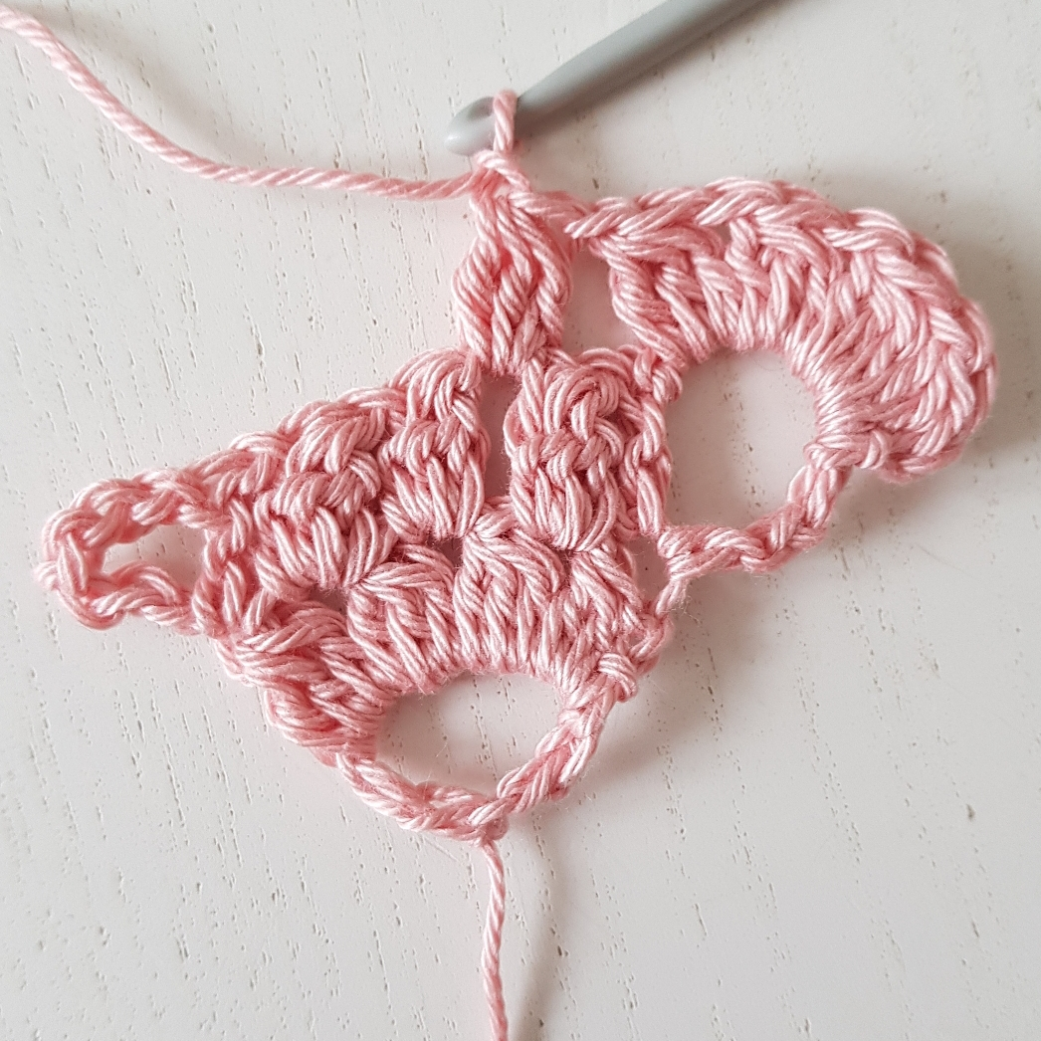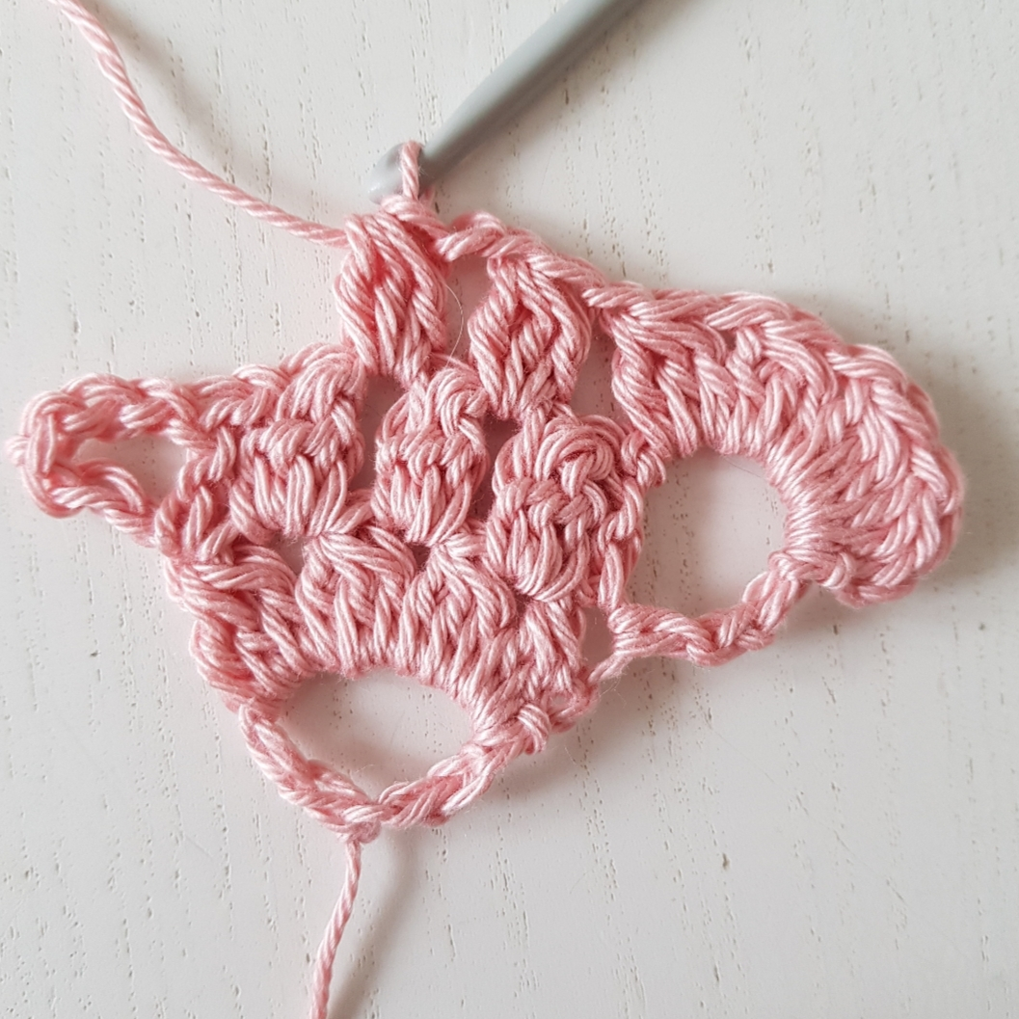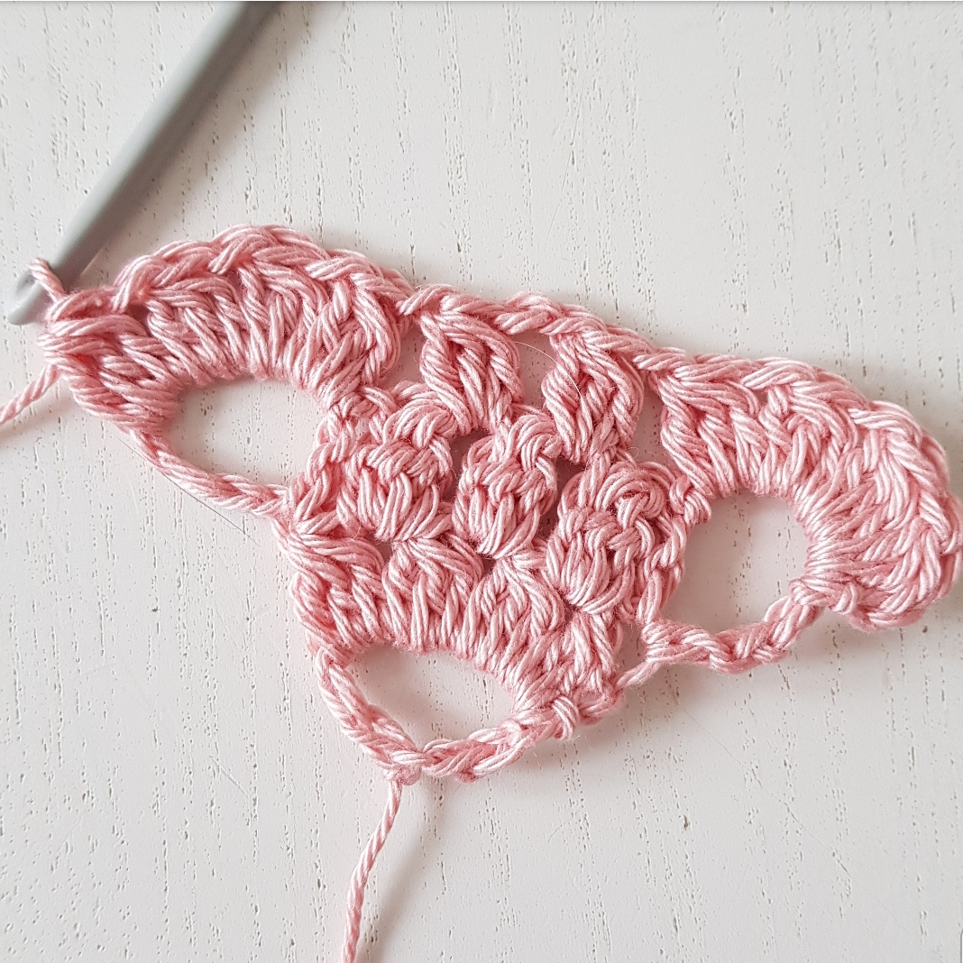

5. Ch 7, 1 dc in the 7th ch from the hook, ch 1, *3 dctog in the ch1-space, ch 1*, repeat ** two more times (= 3 clusters), skip one ch1-space. In the ch2-space (1 dc, ch 3, 1 dc, ch 1), skip one ch1-space, in the next ch1-space *3 dctog, ch 1*, repeat ** two more times (1 dc, ch 3, 1 tr) in the second ch as shown before.

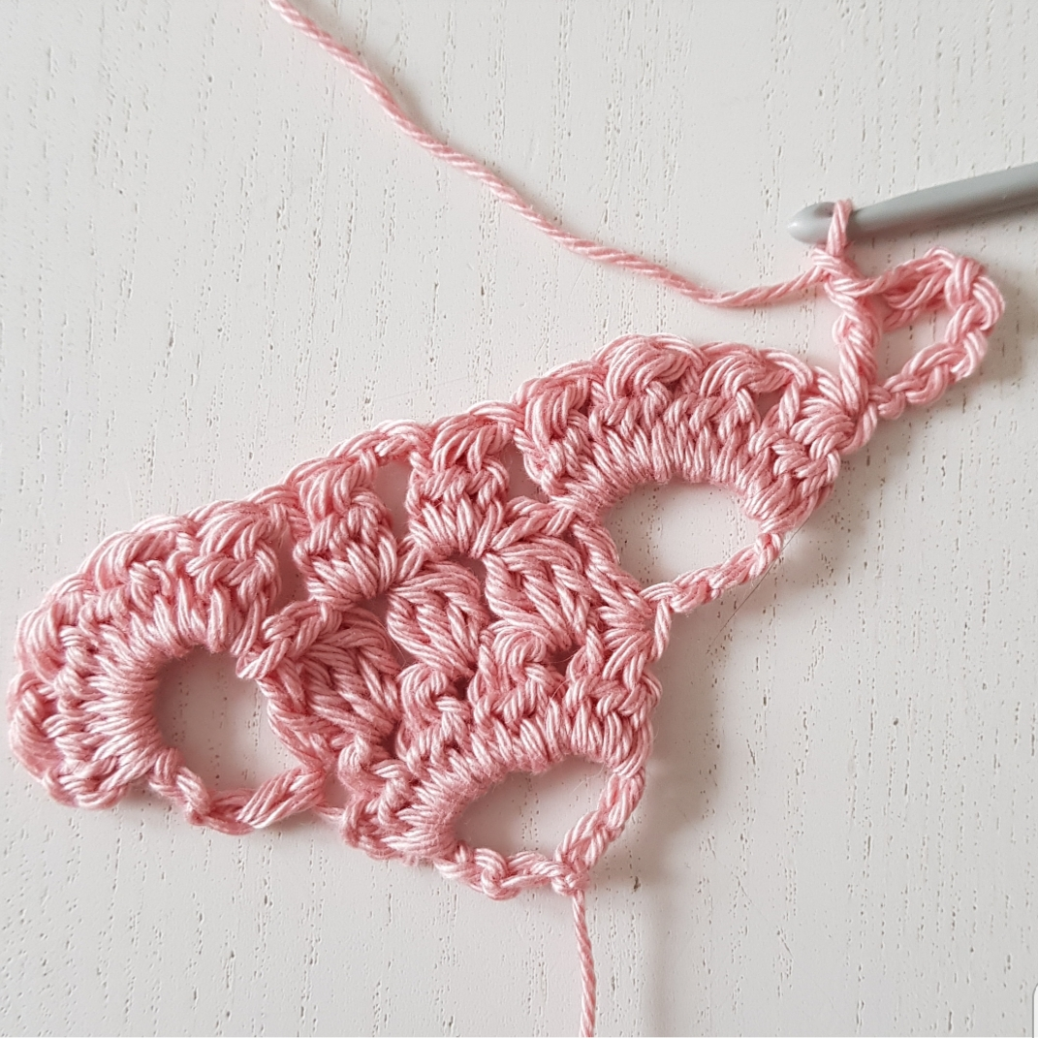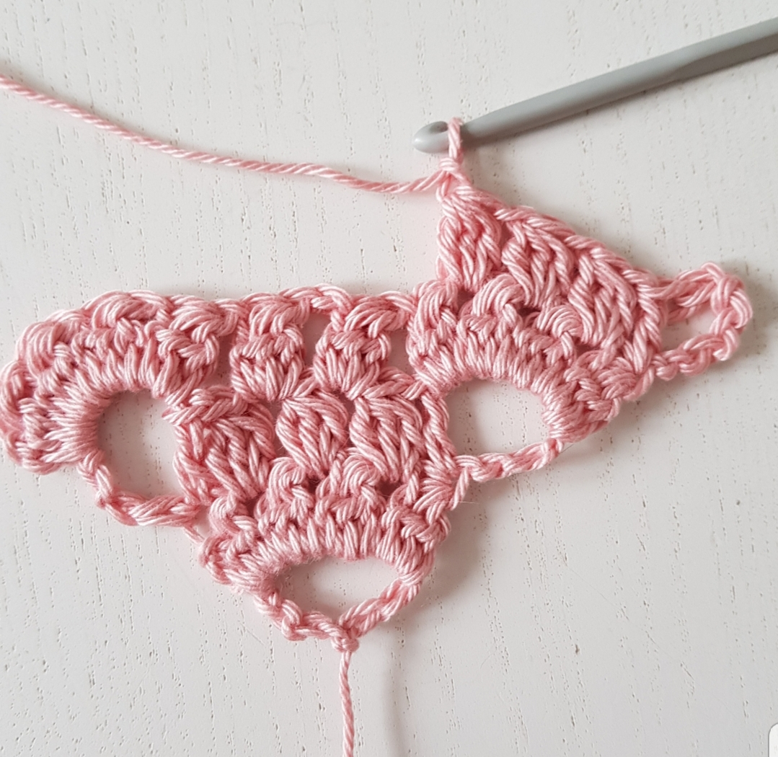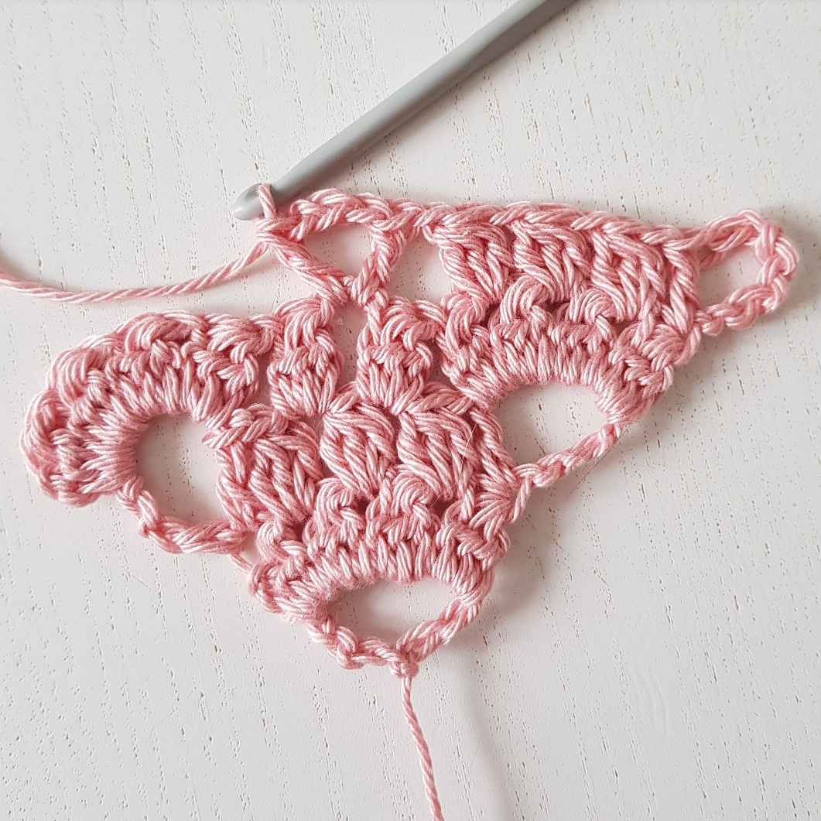
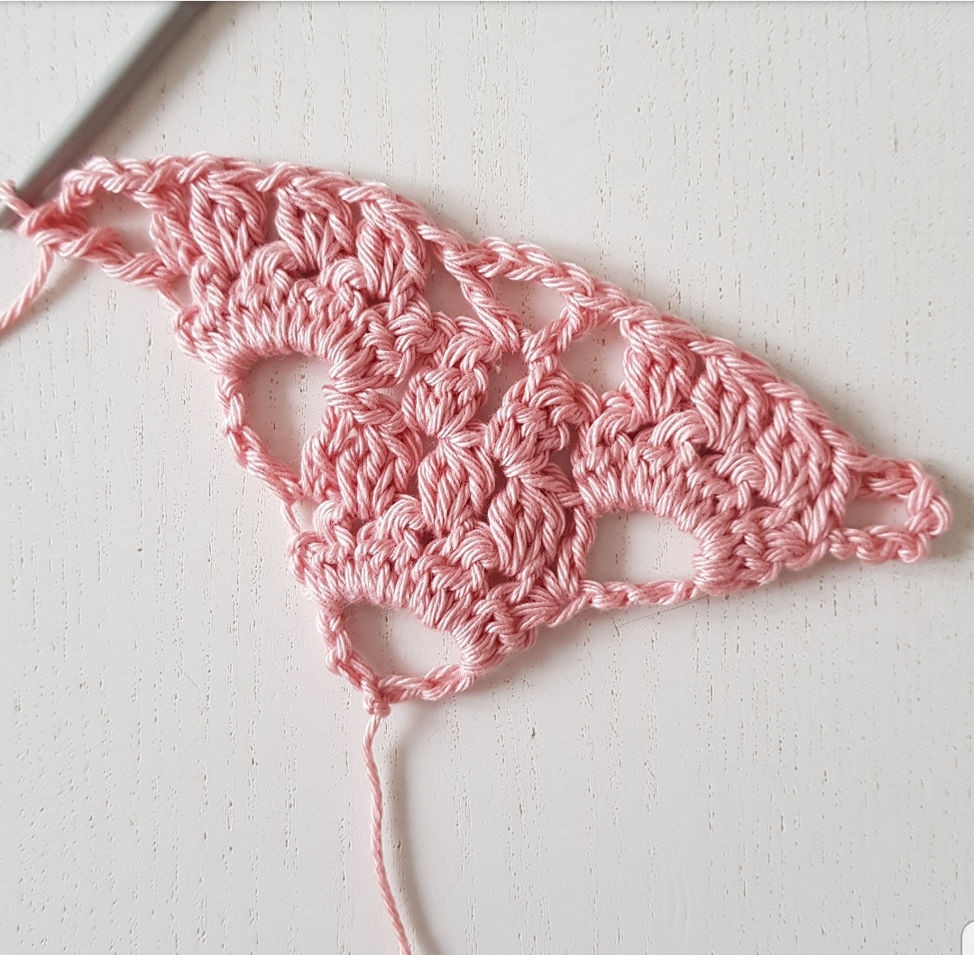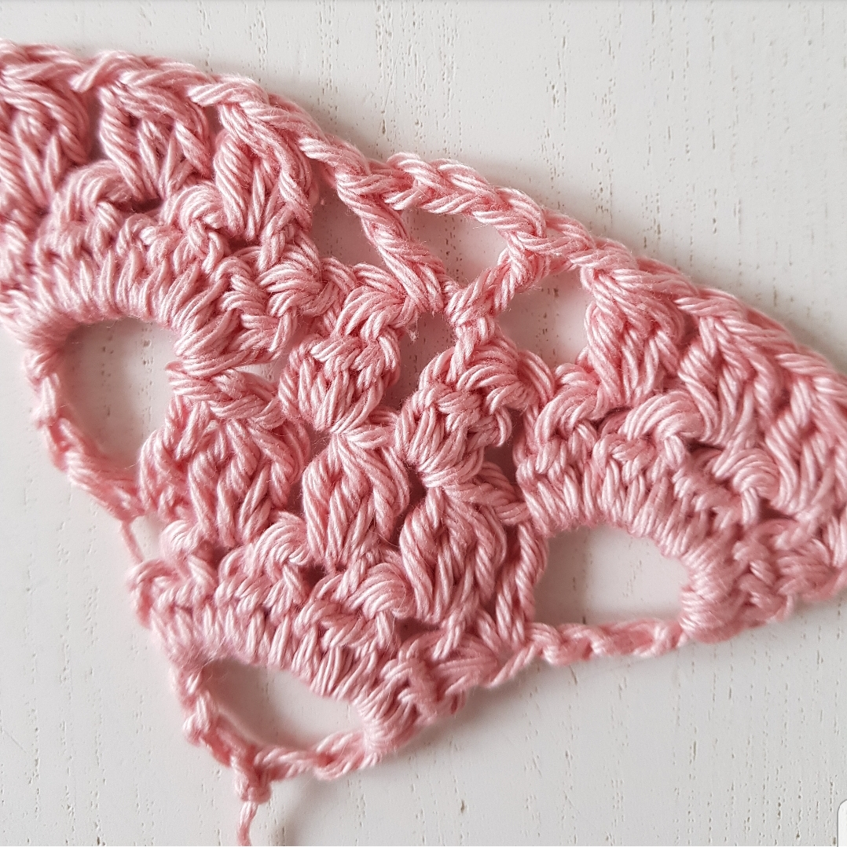

Keep crocheting rows 4-5 until you hafe 15 full brambles, counting from the point and up. End after a row 4.

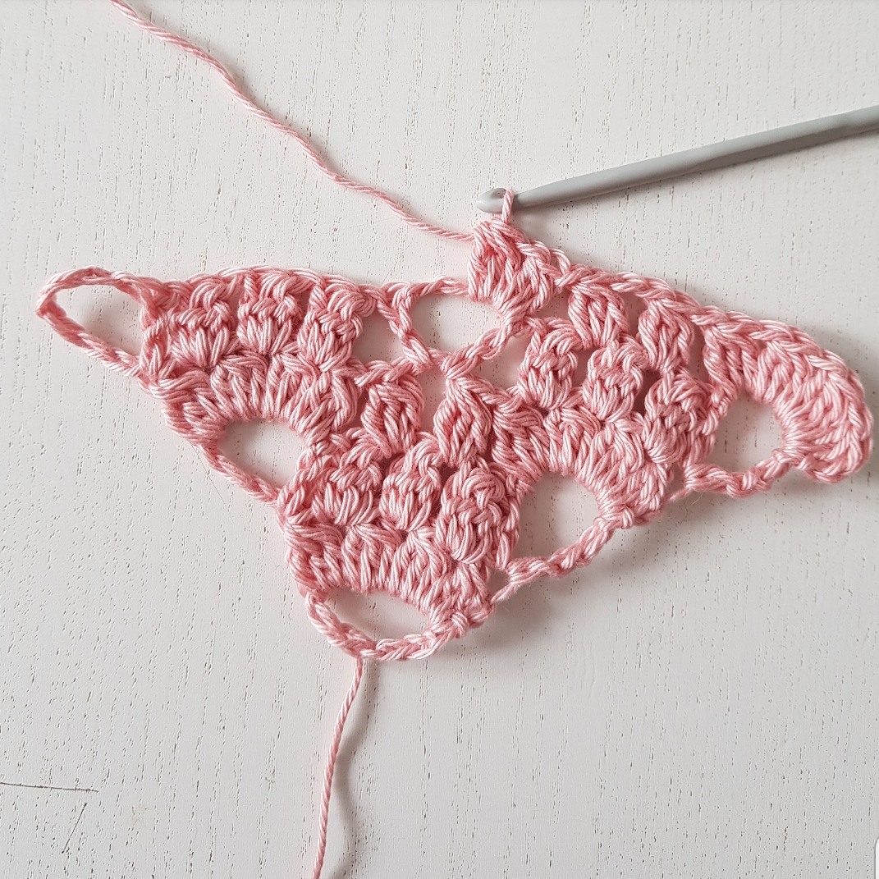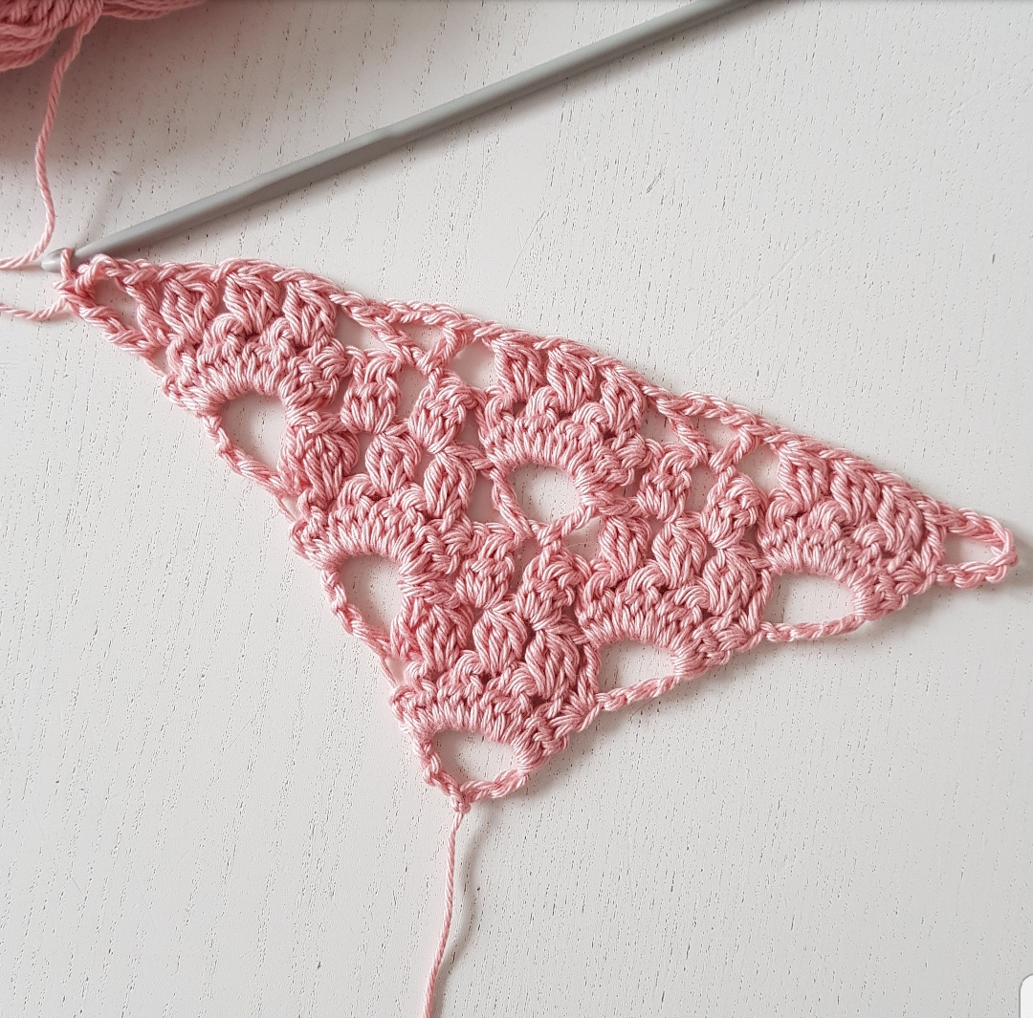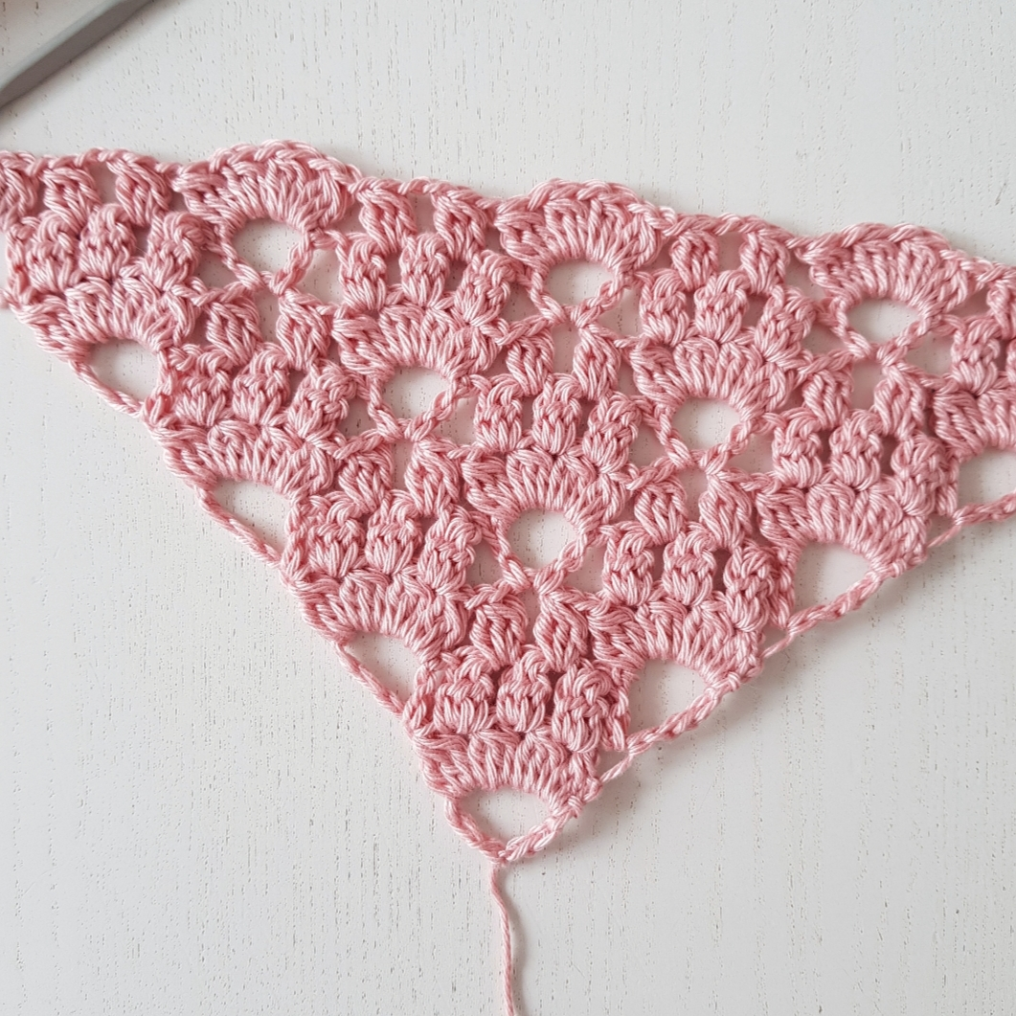

Now its time for edging.

1. 4 dc in the last cluster, (4 dc, ch 2, 4 dc) in each ch-space down to the point. In this ch-space (4 dc, ch 3, 4 dc), and keep crocheting alont the other side of the shawl (4 dc, ch 3, 4 dc) in each ch-space. End with 4 dc in the first cluster.

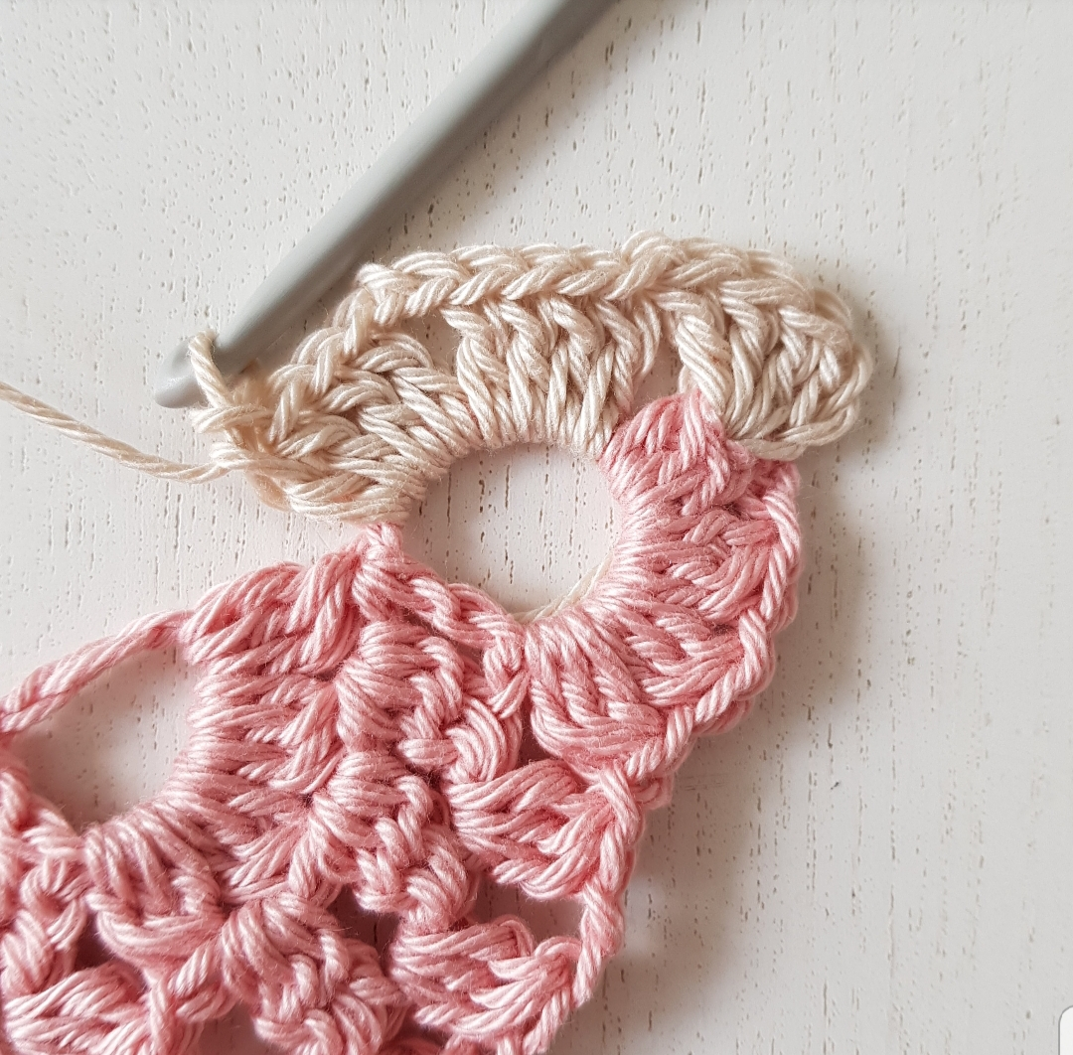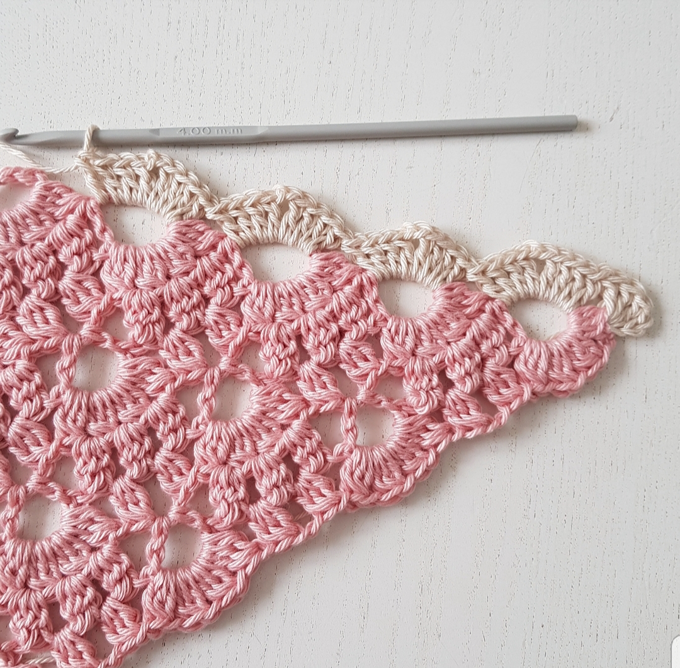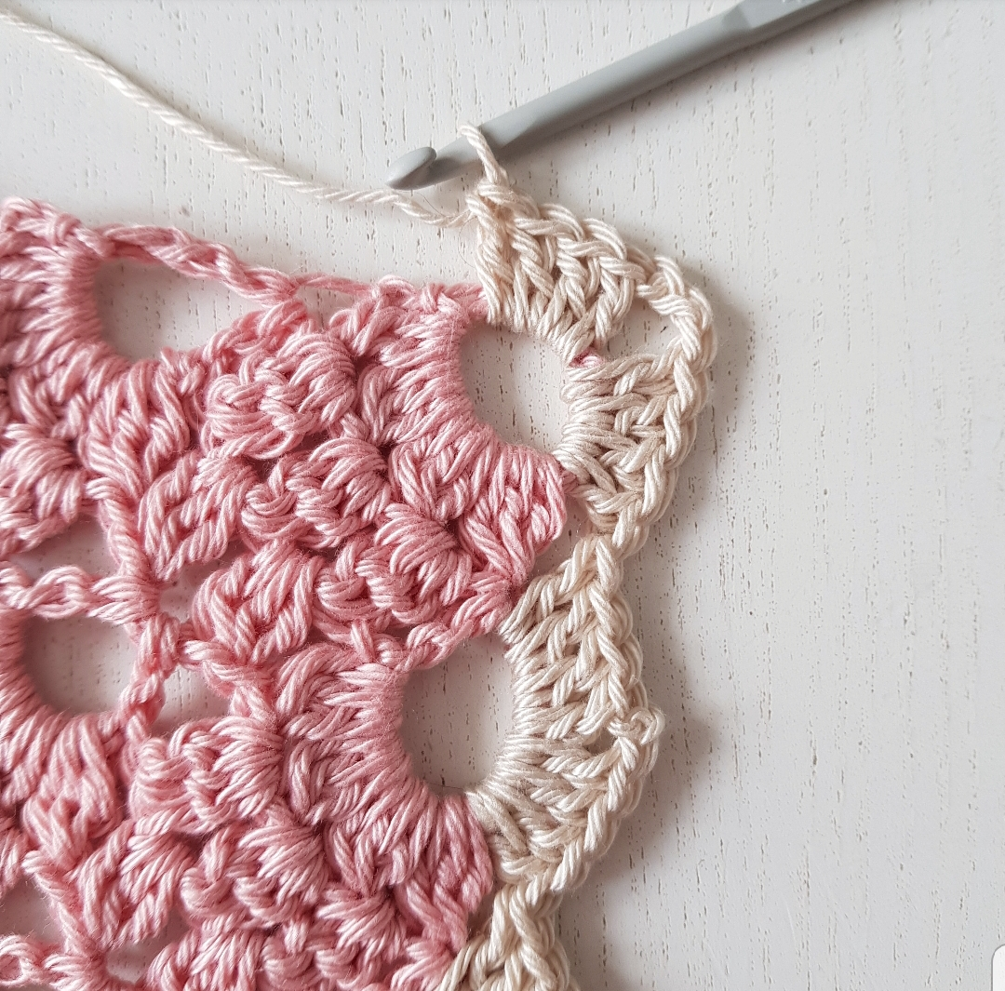
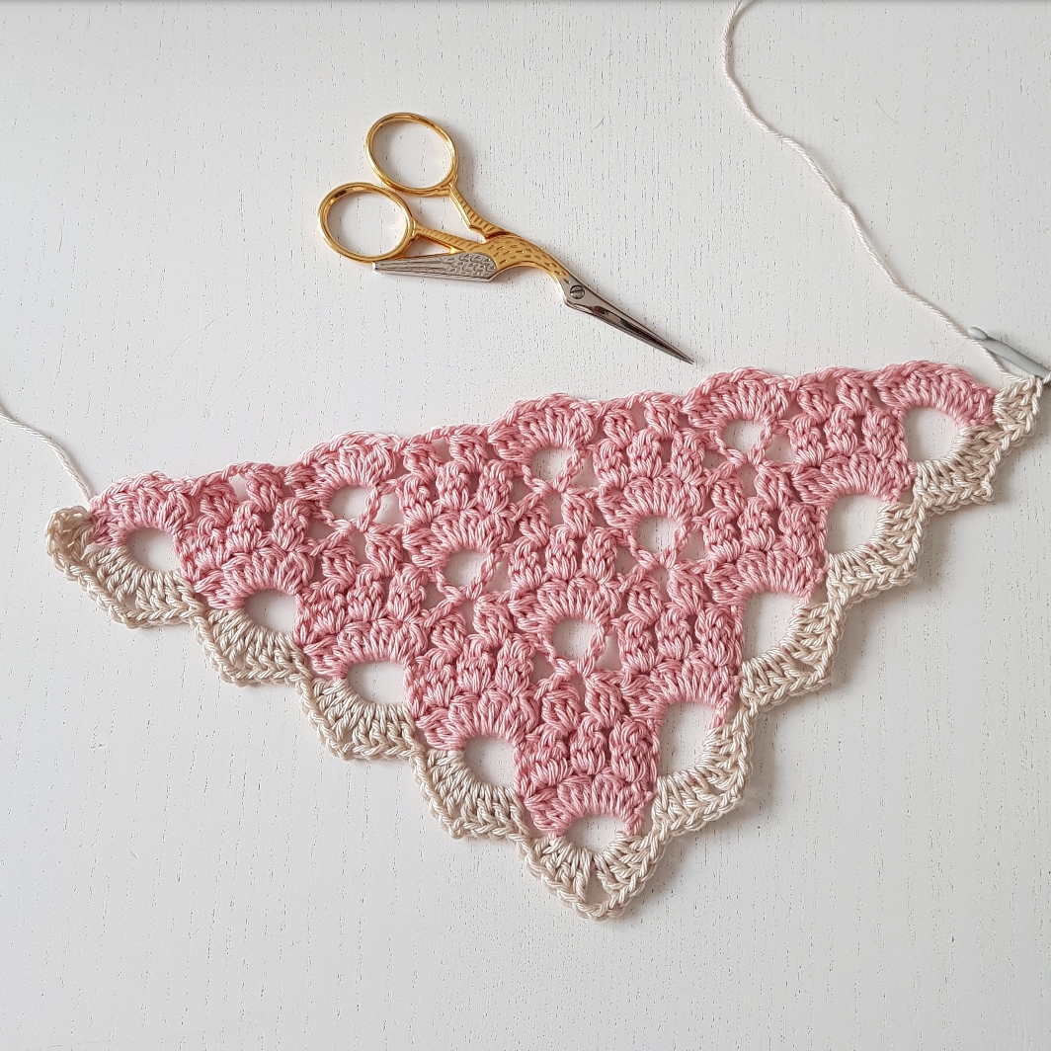

2. Ch 3, 3 dc in the first dc, 1 dc between the first two clusters, *(4 dc, ch 2, 4 dc) in the ch-space*, repeat ** along the first side of the shawl, in the ch-space at the point (5 dc, ch 3, 5 dc), and along the other side of the shawl *(4 dc, ch 2, 4 dc)*, repeat** and end with 4 dc in the last stitch.

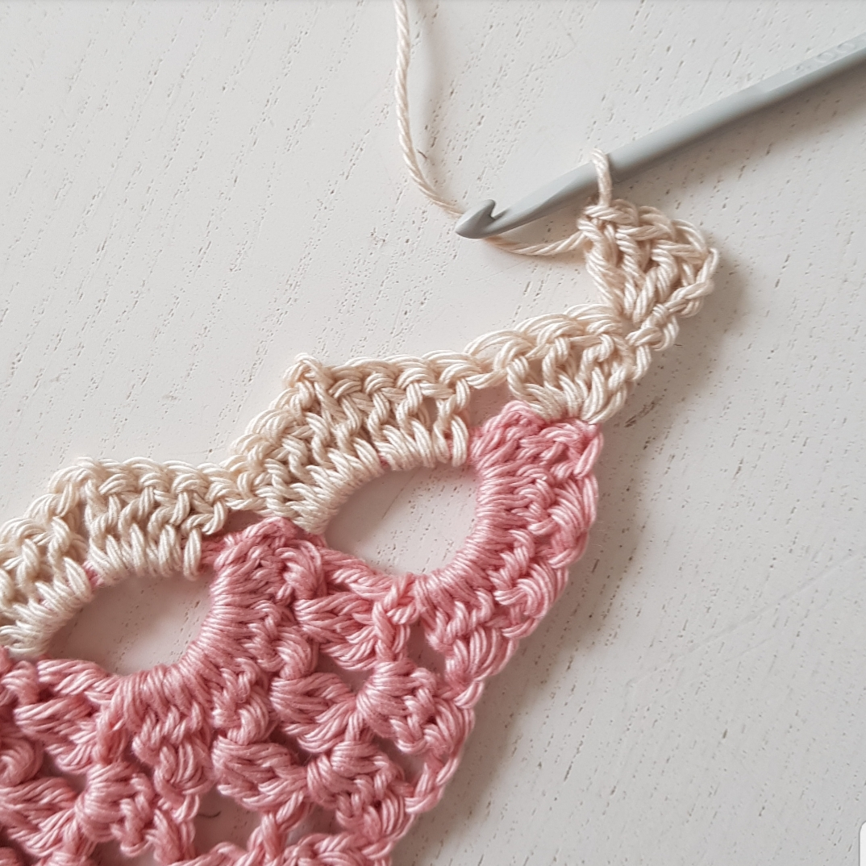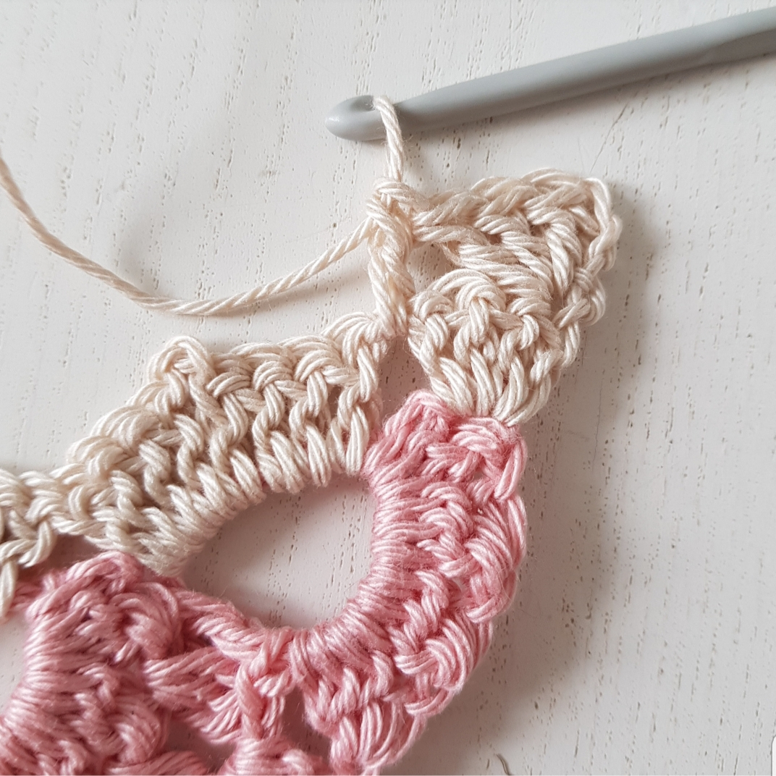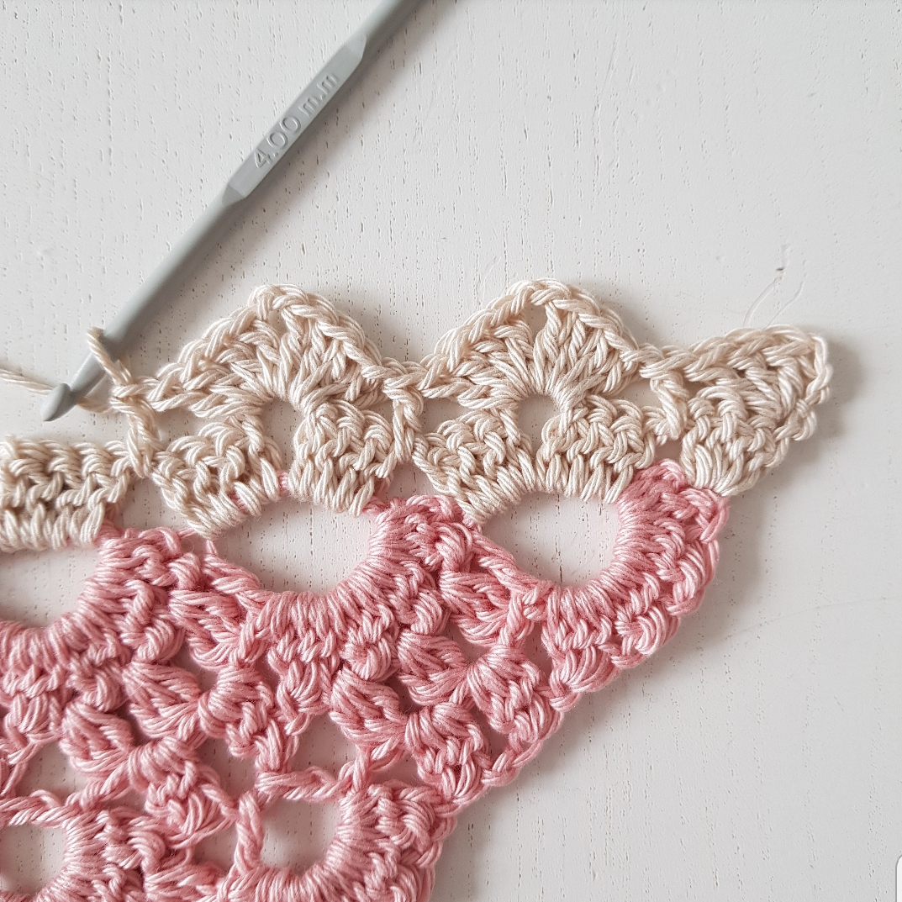

3. Ch 1, 1 sc in each of the first 4 dc, 1 fpsc in the dc, *1 sc in each of following 4 dc, (1 sc, ch 1, 1 sc) in the ch2-space, 1 sc in each of following 4 dc, 1 fpsc in the dc*, repeat ** until you reach the point, 1 sc in each of the first 5 dc, (1 sc, ch 1, 1 sc) in the ch2-space, 1 sc in each of following 5 dc, 1 fpsc in the dc, *1 sc in each of following 4 dc, (1 sc, ch 1, 1 sc) in the ch2-space, 1 sc in each of following 4 dc, 1 fpsc in the dc*, repeat** along the side and end with 1 sc in each of the last 4 dc.

